Hands-on 1:
PL/SQL programming

Exercise 1 :
Control Structures :

Step 1: Create Customers Table

CREATE TABLE Customers (
CustomerID NUMBER PRIMARY KEY,
Name VARCHAR2(50),
Age NUMBER,
Balance NUMBER,
IsVIP VARCHAR2(5)
);

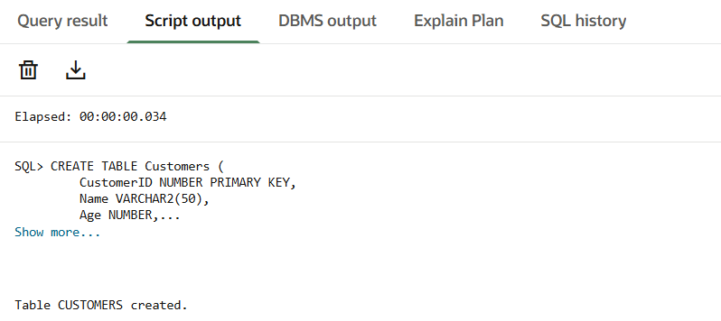

Step 2: Create Loans Table

CREATE TABLE Loans (
LoanID NUMBER PRIMARY KEY,
CustomerID NUMBER,
InterestRate NUMBER,
DueDate DATE
);

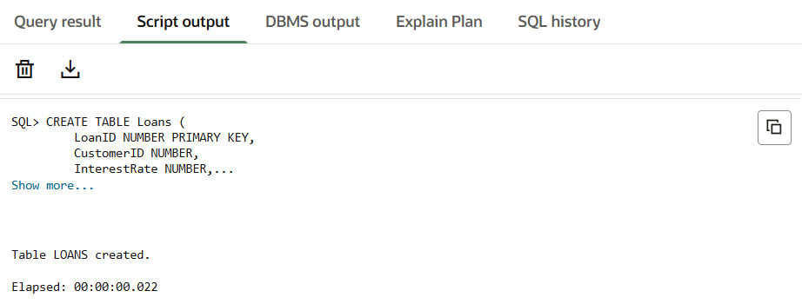

Step 3: Insert Sample Data into Customers

INSERT INTO Customers VALUES (1, 'Rajesh Kumar', 65, 12000, 'FALSE');
INSERT INTO Customers VALUES (2, 'Meena Sharma', 70, 15000, 'FALSE');
INSERT INTO Customers VALUES (3, 'John Smith', 45, 8000, 'FALSE');

COMMIT;

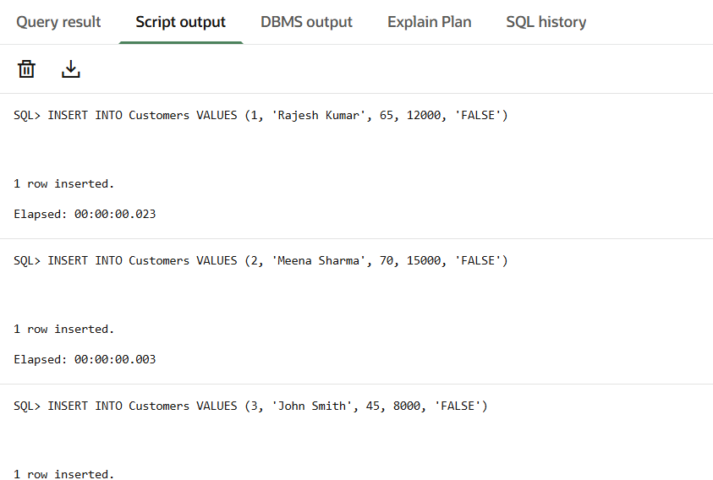

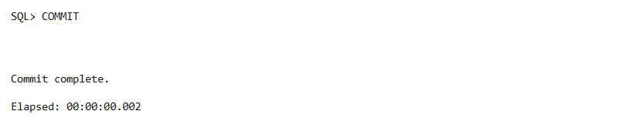

Step 4: Insert Sample Data into Loans

INSERT INTO Loans VALUES (101, 1, 9, SYSDATE + 10);
INSERT INTO Loans VALUES (102, 2, 8, SYSDATE + 20);
INSERT INTO Loans VALUES (103, 3, 10, SYSDATE + 40);

COMMIT;

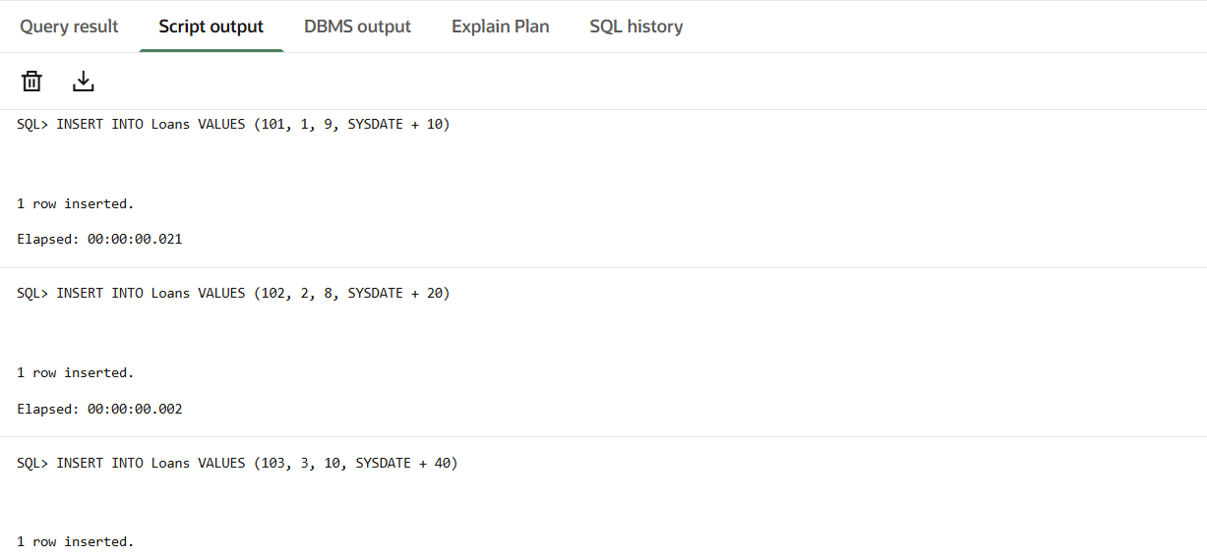
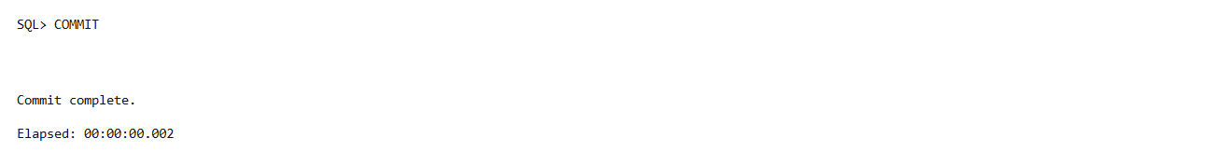

Scenario 1 :
DECLARE
BEGIN
FOR rec IN (
SELECT c.CustomerID, c.Name, c.Age, l.LoanID, l.InterestRate
FROM Customers c
JOIN Loans l
ON c.CustomerID = l.CustomerID
)
LOOP
IF rec.Age > 60 THEN
UPDATE Loans
SET InterestRate = InterestRate - 1
WHERE LoanID = rec.LoanID;

DBMS_OUTPUT.PUT_LINE('Discount applied to ' || rec.Name);
END IF;
END LOOP;

COMMIT;
END;
/
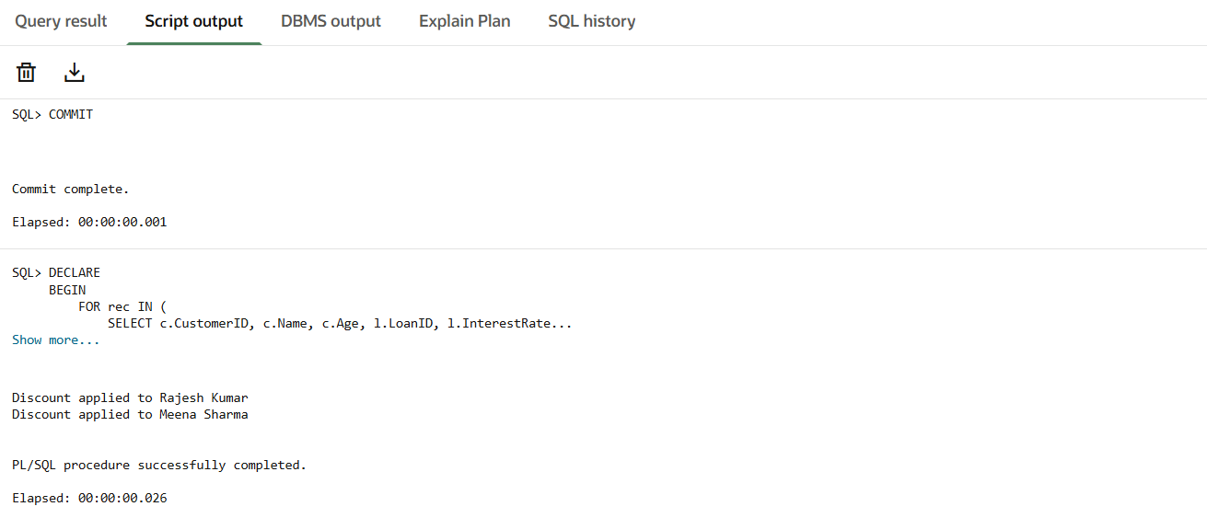

SELECT * FROM Loans;

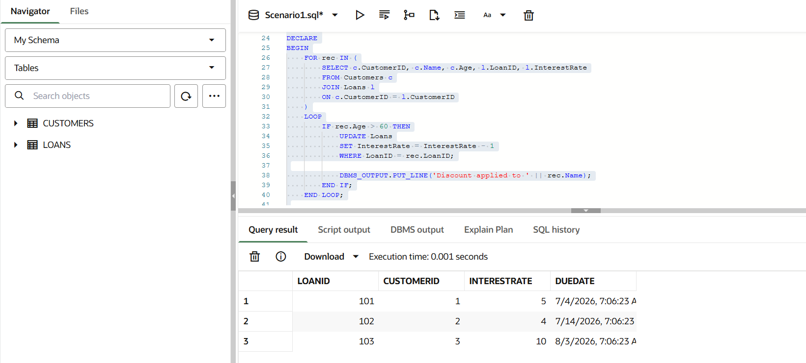

Scenario 2 :
DECLARE
BEGIN
FOR rec IN (
SELECT CustomerID, Name, Balance
FROM Customers
)
LOOP
IF rec.Balance > 10000 THEN
UPDATE Customers
SET IsVIP = 'TRUE'
WHERE CustomerID = rec.CustomerID;
END IF;
END LOOP;

COMMIT;
END;
/
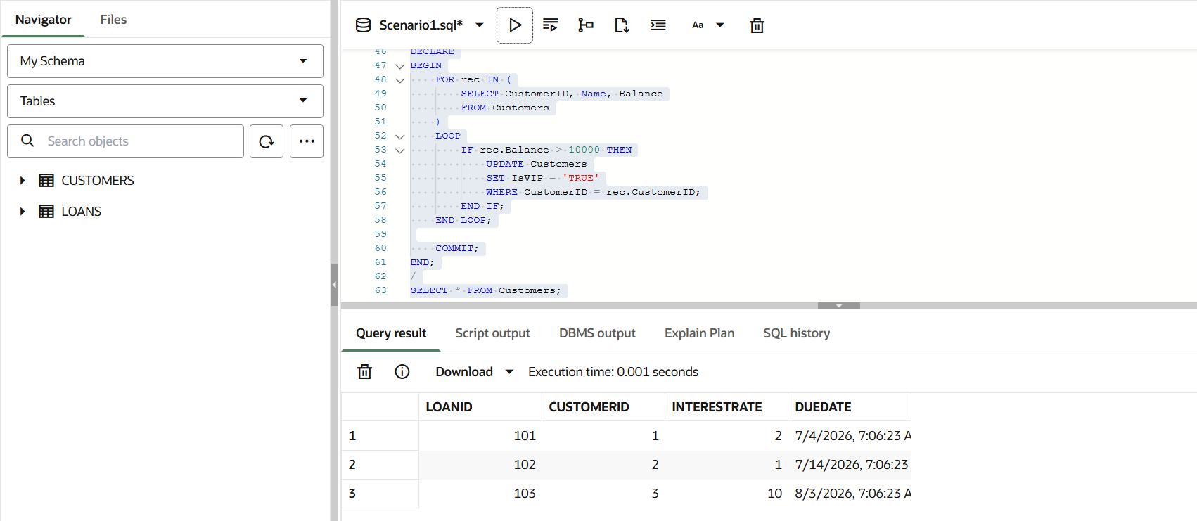

Scenario 3 :
DECLARE
BEGIN
FOR rec IN (
SELECT c.Name, l.LoanID, l.DueDate
FROM Customers c
JOIN Loans l
ON c.CustomerID = l.CustomerID
WHERE l.DueDate BETWEEN SYSDATE AND SYSDATE + 30
)
LOOP
DBMS_OUTPUT.PUT_LINE(
'Reminder: ' || rec.Name ||
', Loan ID: ' || rec.LoanID
);
END LOOP;
END;
/
SELECT c.Name, l.LoanID, l.DueDate
FROM Customers c
JOIN Loans l
ON c.CustomerID = l.CustomerID
WHERE l.DueDate BETWEEN SYSDATE AND SYSDATE + 30;
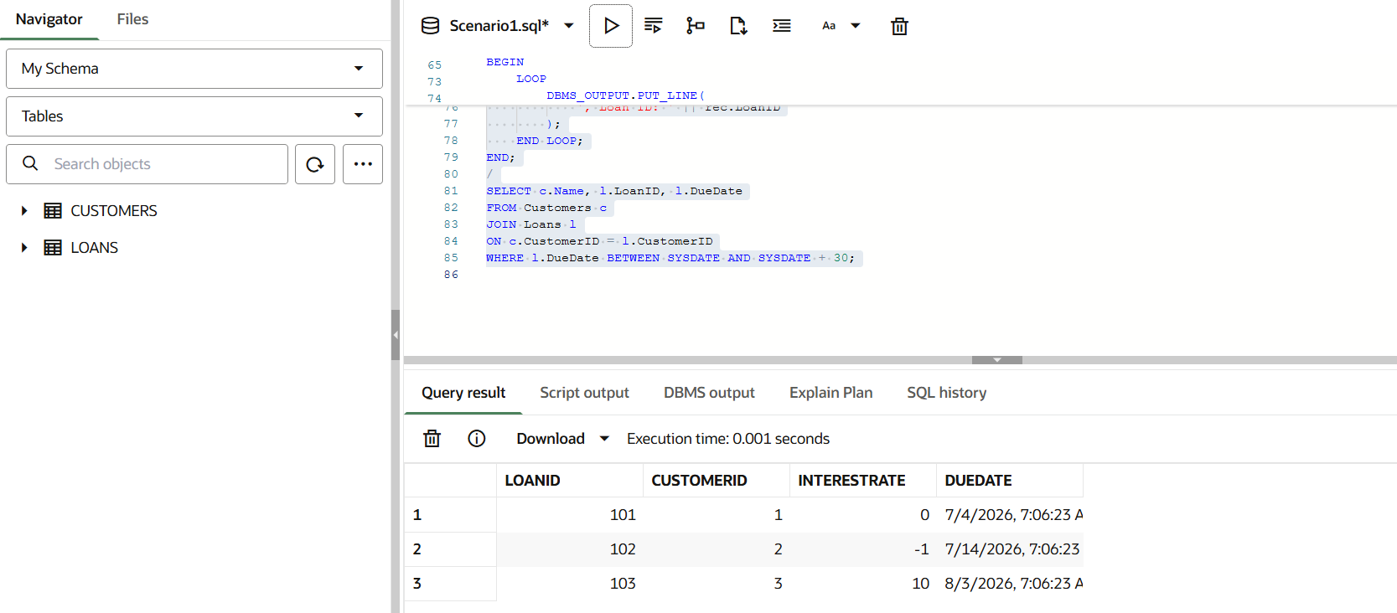

Exercise 3 :
Stored Procedures :

Step 1: Create Tables

CREATE TABLE Accounts (
AccountID NUMBER PRIMARY KEY,
CustomerName VARCHAR2(50),
AccountType VARCHAR2(20),
Balance NUMBER(10,2)
);

INSERT INTO Accounts VALUES (101,'Ram','Savings',10000);
INSERT INTO Accounts VALUES (102,'Priya','Savings',20000);
INSERT INTO Accounts VALUES (103,'Arun','Current',15000);

COMMIT;

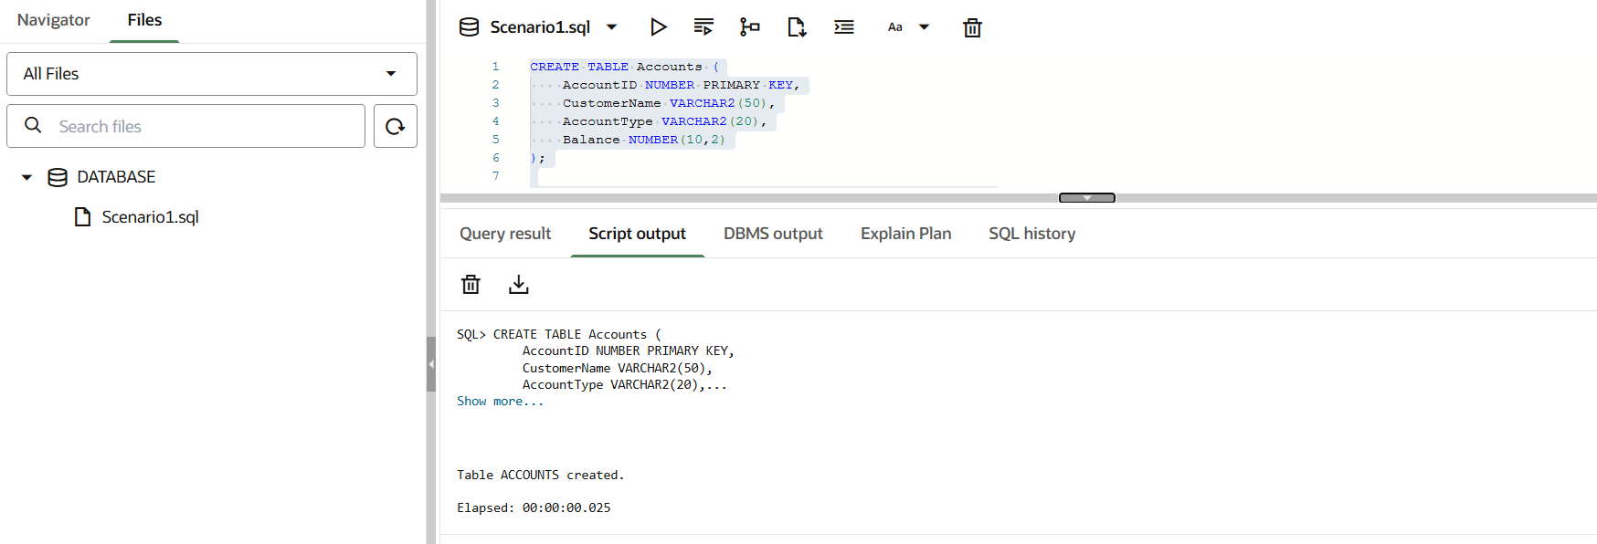

Step 2: Employees Table

CREATE TABLE Employees (
EmpID NUMBER PRIMARY KEY,
EmpName VARCHAR2(50),
Department VARCHAR2(20),
Salary NUMBER(10,2)
);

INSERT INTO Employees VALUES (1,'John','IT',50000);
INSERT INTO Employees VALUES (2,'Mary','IT',60000);
INSERT INTO Employees VALUES (3,'David','HR',45000);

COMMIT;
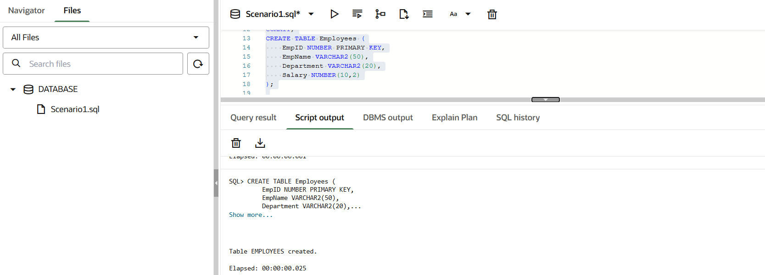

Scenario 1 :
CREATE OR REPLACE PROCEDURE ProcessMonthlyInterest
AS
BEGIN
UPDATE Accounts
SET Balance = Balance * 1.01
WHERE AccountType = 'Savings';

COMMIT;
END;
/
BEGIN
ProcessMonthlyInterest;
END;
/
SELECT * FROM Accounts;

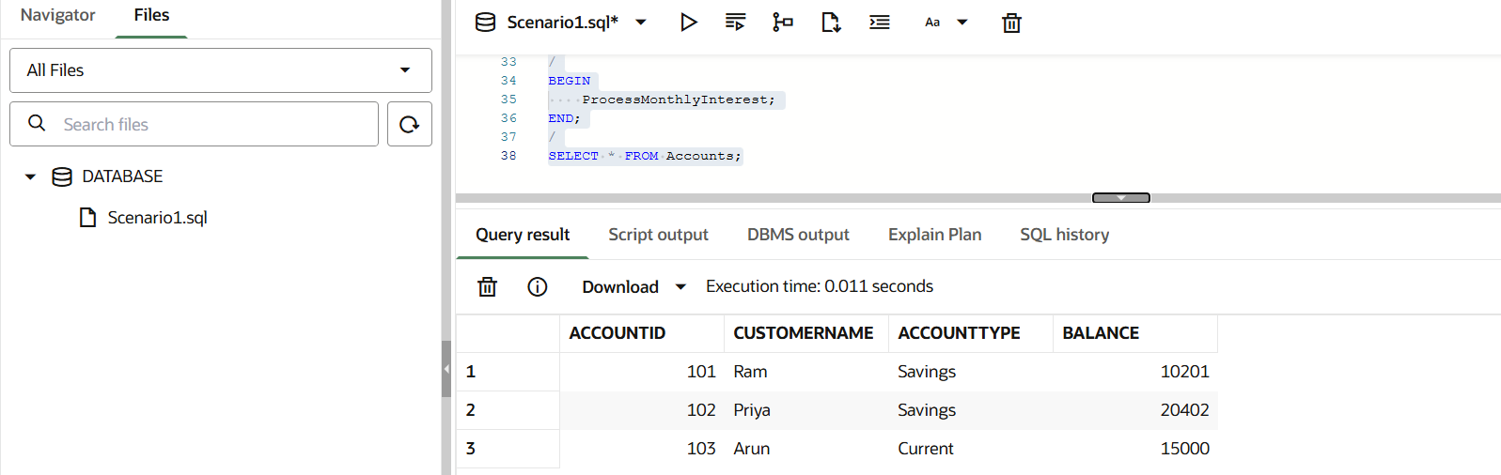

Scenario 2 :
CREATE OR REPLACE PROCEDURE UpdateEmployeeBonus(
p_department VARCHAR2,
p_bonus NUMBER
)
AS
BEGIN
UPDATE Employees
SET Salary = Salary + (Salary * p_bonus/100)
WHERE Department = p_department;

COMMIT;
END;
/
BEGIN
UpdateEmployeeBonus('IT',10);
END;
/
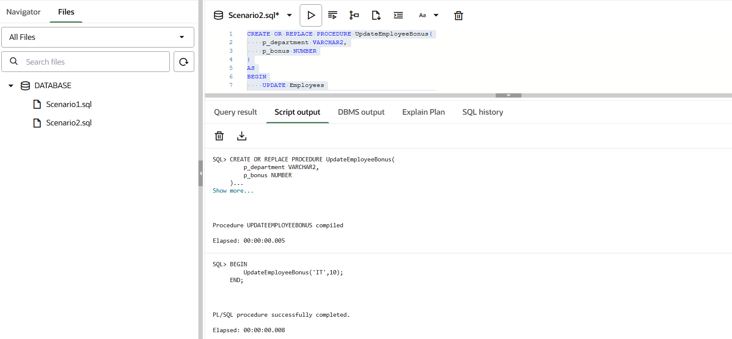

SELECT * FROM Employees;

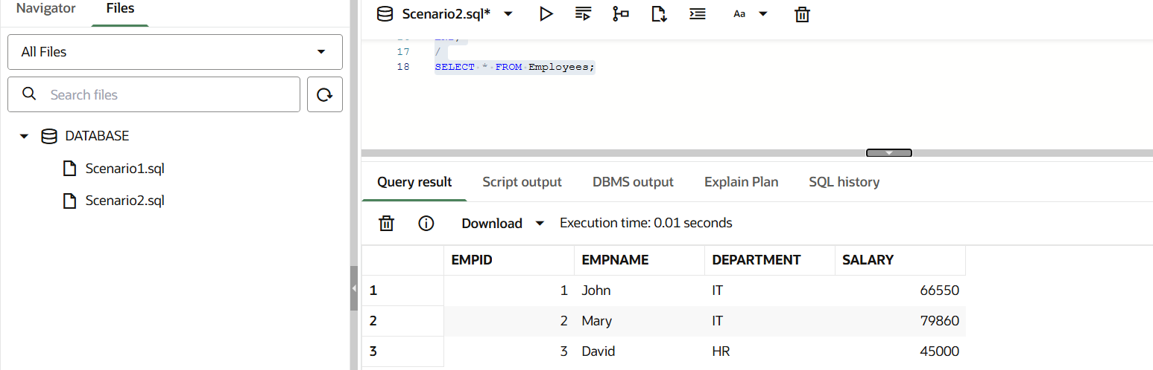

Scenario 3 :
CREATE OR REPLACE PROCEDURE TransferFunds(
p_from NUMBER,
p_to NUMBER,
p_amount NUMBER
)
AS
v_balance NUMBER;
BEGIN

SELECT Balance
INTO v_balance
FROM Accounts
WHERE AccountID = p_from;

IF v_balance >= p_amount THEN

UPDATE Accounts
SET Balance = Balance - p_amount
WHERE AccountID = p_from;

UPDATE Accounts
SET Balance = Balance + p_amount
WHERE AccountID = p_to;

COMMIT;

END IF;
END;
/
BEGIN
TransferFunds(101,102,5000);
END;
/

SELECT * FROM Accounts;
